**Case Study 1**

Step 3 – Plan the solution

Create decision logic

* Show menu
* If item from menu selected, add item to list
  + If item exists on list, increase count by 1
* If remove selected, ask item
  + When item input, remove item from list
* Does a deal exist for a combination of items?
  + Replace items in the list with the deal and adjust price
* If payment selected, confirm cash or card
  + If cash, input amount of cash received, and display change
  + If card, send request to eftpos machine to accept payment
* When payment accepted, print receipt
* If items no longer required
  + Reset list of items selected

Error detection

* If payment declines, return to payment type
* 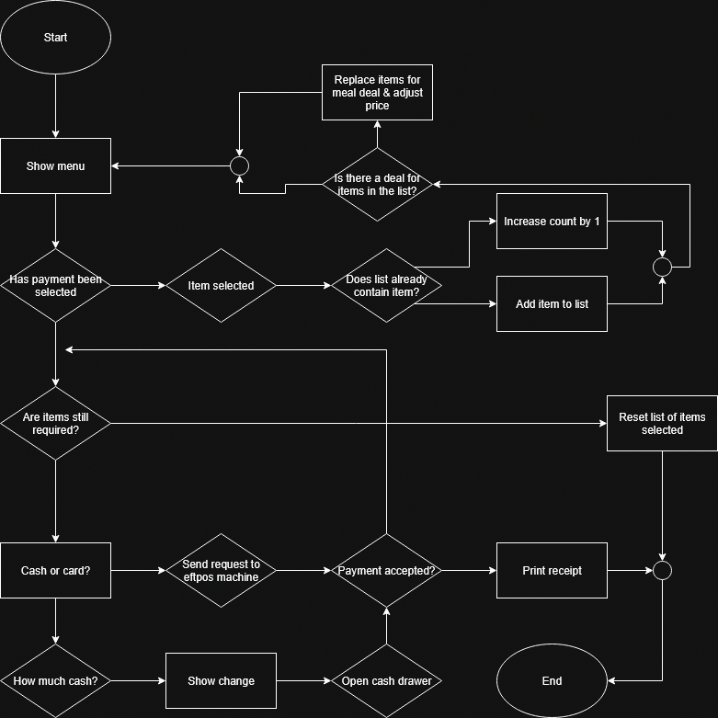Potential to add a confirmation screen if the user adds more than >=10 of 1 item to make sure they didn’t add them by mistake